**========Git Project=======**

Task1: create a repository in github

● Git init

● Both config commands

Task2: open git bash and clone contents from remote repository

● clone

● show the folder in local repository

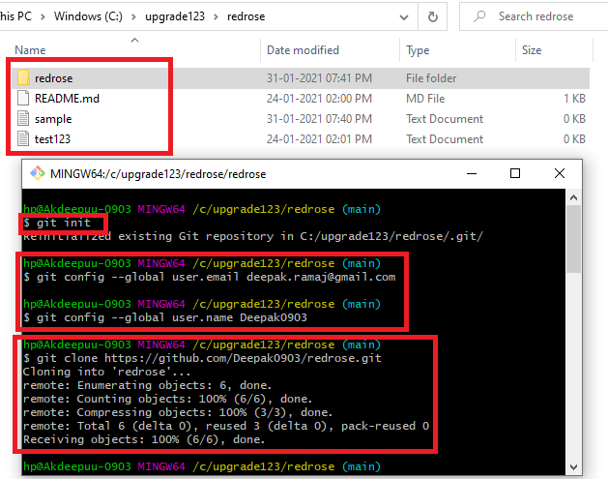

**Task 1**

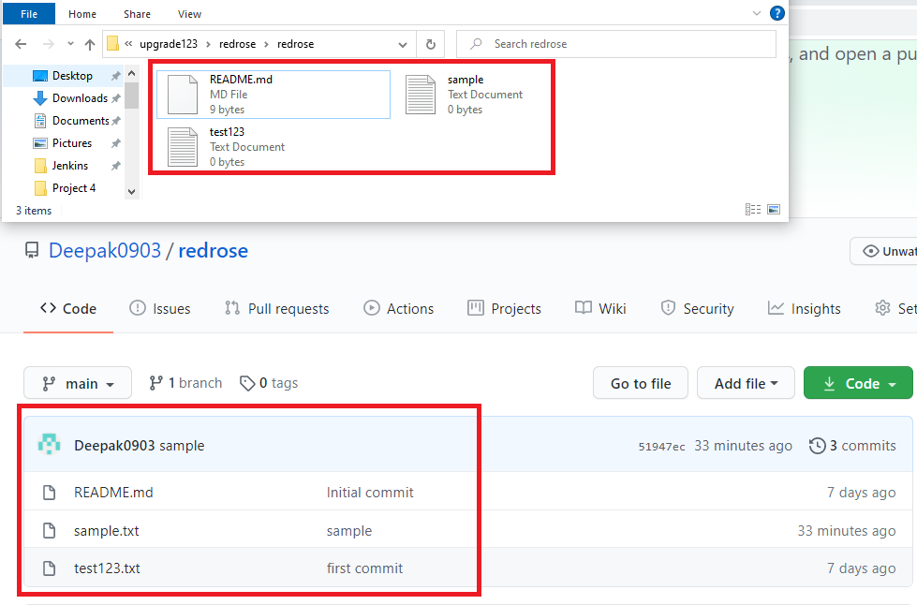

**Task 2**

Task3: create a file in the local space and push it to the remote repository

● add

● commit

● push successful

● show the file in remote repository

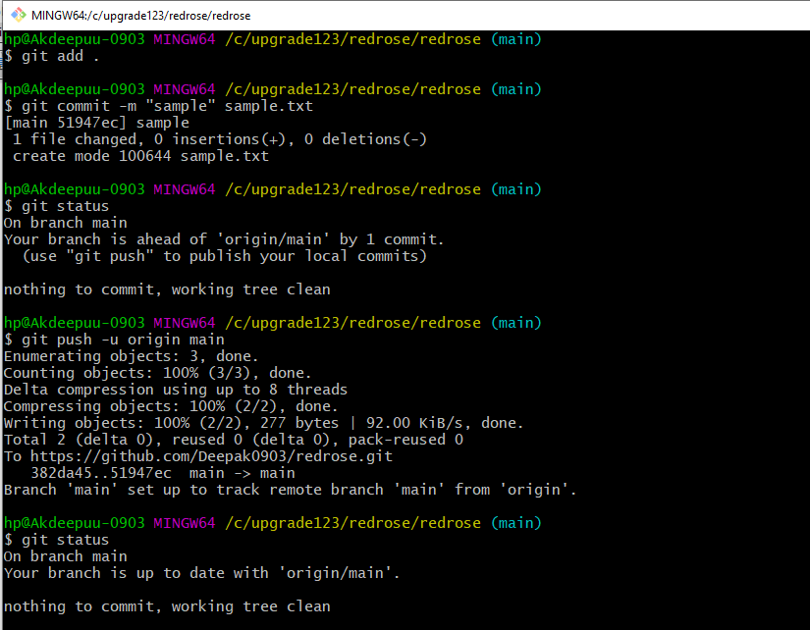

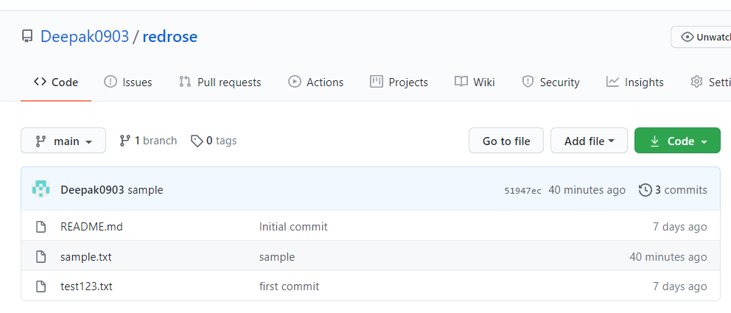

**Task 3**

Task4: Branching and merging

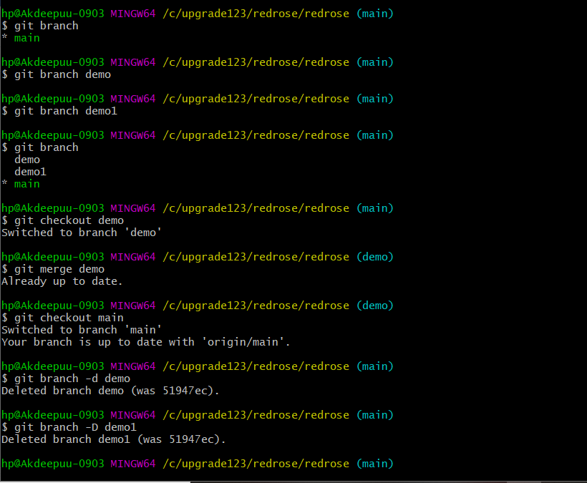

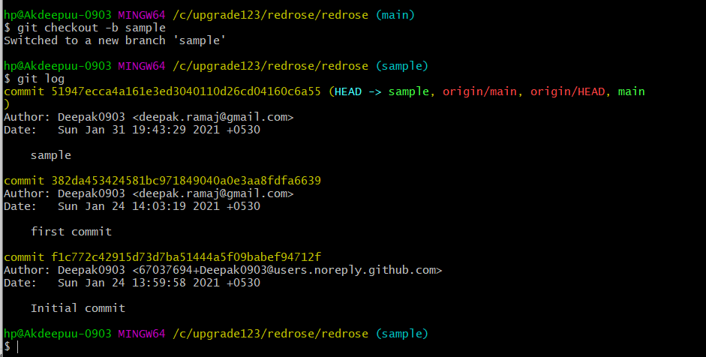

**Task 4**